SIMATS ENGINEERING (SAVEETHA SCHOOL OF ENGINEERING)
Department of Computer Science and Engineering
ASSESSMENT TOOL 1 – Constraint-Based Problem Solving

Course Code: | CSA06 |  | Course Title: | Design and Analysis of Algorithms
CO Assessed: | CO5– Naturalization (BL5,BL6) |  | Assessment: | Assessment Tool 1 – Constraint Based Problem Solving
Weightage: | 30% of CIA |  | Total Marks: | 100 (2 Questions × 50 Marks)
CO5 Statement: | Analyze computational problems using backtracking techniques and complexity classes such as P, NP, NP-Hard, and NP-Complete for combinatorial problem solving.
Student Name: | CH.Akhil |  | Reg. No.: | 192525250
Section / Batch: | 2025 |  | Date: | 31 08 26
Instructions to Students
- • Answer BOTH questions. Each question carries 50 Marks. Total: 100 Marks.
- Apply backtracking techniques systematically for combinatorial problem solving.
- Clearly classify problems under P, NP, NP-Hard, and NP-Complete categories wherever required.
- Provide proper justification, state-space representation, and complexity analysis for all solutions.
- Neat presentation and logical explanation are mandatory.
Question Type |  | Focus Area |  |  | Questions Marks
Constraint Based Problem Solving |  | Analyze combinatorial problems using backtracking and complexity classes such as P, NP, NP-Hard, and NPComplete. |  |  | Q1 – Q2 | Q1 –50 Q2 –50
 |  | GRAND TOTAL: |  |  | 100 Marks
SECTION A – CONSTARINT BASED PROBLEM SOLVING

1.
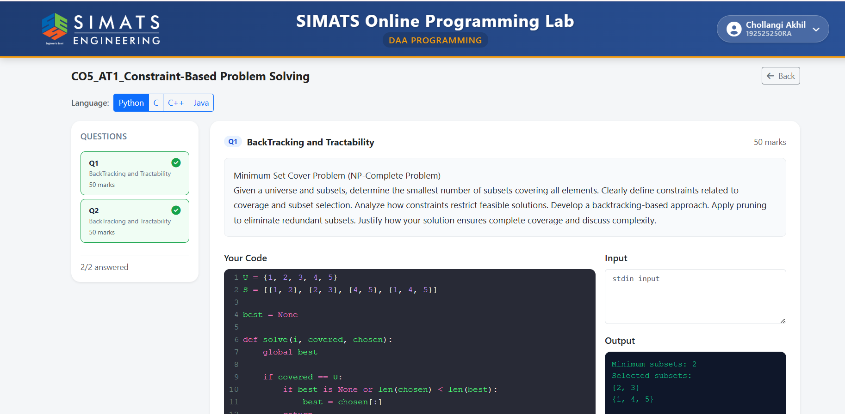

2.
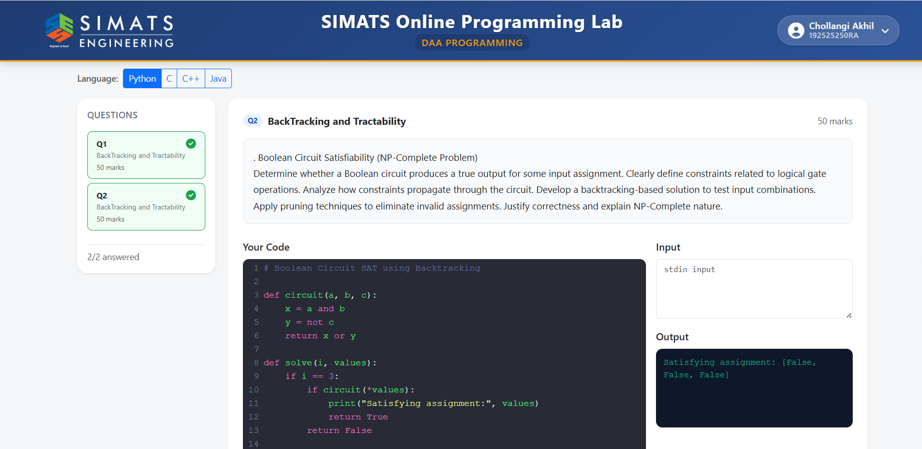

Code of Conduct
I CH.Akhil (192525250) certify that this submission is my original work and that I have adhered to the guidelines specified for this assessment. I understand that any violation of academic integrity rules will result in disciplinary action.
Signature of the Student: ch.akhil
Faculty In-charge | Course Coordinator | Head of Department
Signature: _______________ | Signature: _______________ | Signature: _______________
Date: ___________________ | Date: ___________________ | Date: ___________________
RUBRICS FOR CALCULATION

Criteria | Wt. | Level 4 – Exemplary | Level 3 – Proficient | Level 2 –  Developing | Level 1 –  Beginning
Problem Understa ndin g | 25% | Clearly defines the problem and identifies all relevant constraints accurately | Identifies most constraints with minor gaps | Partial understandi ng; misses key constraints | Fails to identify constraints correctly
Constrain t Analysis | 25% | Analyzes constraints effectively and prioritizes them logically | Provides  reasonable analysis with some  prioritizatio n | Limited analysis; weak prioritization | No meaningful analysis or prioritization
Solution Develop ment | 25% | Develops optimal and feasible solutions satisfying all constraints | Develops workable solutions with minor  limitations | Solutions partially satisfy constraints | Solutions do not meet constraints
Applicatio n of  Concepts | 15% | Effectively applies appropriate concepts, methods, or tools | Applies concepts with minor errors | Limited application; requires guidance | Unable to apply relevant concepts
Justificati  on | 10% | Provides strong justification for decisions with logical reasoning | Provides  justification with some clarity | Weak or unclear justification | No justification provided
Marks Evaluation:
Questio n No. | Problem  Understanding (25%) | Constraint  Analysis  (25%) | Solution  Developmen  t  (25%) | Applicatio n of  Concepts  (15%) | Justificatio n  (10%) | Total Marks (Each – 50)
Q1
Q2
 |  |  |  | Overall Total (100)

